GET https://graph.microsoft.com/v1.0/teams/d52785e5-bbb2-4e64-9fba-e4ee92e7a772/channels/19%3A31dE8jD0ThCt4D21URf4SLzxH8jX4UrximNQsLvfmSk1%40thread.tacv2/messages

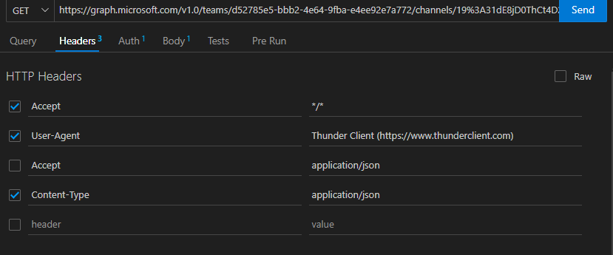

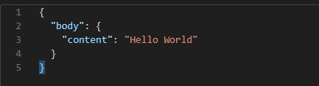

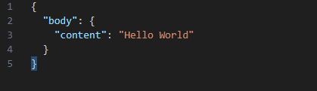

Post https://login.microsoftonline.com/511ce045-2e79-4f6a-b955-606980ab7992/oauth2/v2.0/token

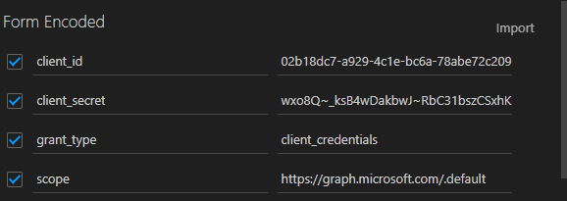

[Send chatMessage in a channel or a chat - Microsoft Graph v1.0 | Microsoft Learn](https://learn.microsoft.com/en-us/graph/api/chatmessage-post?view=graph-rest-1.0&tabs=http)